

**MATHEMATICS:**

**SPECIALIST 1 & 2**

**SEMESTER 1 2018**

**TEST 3**

**Name_____________________**

**Calculator Free**

Reading time: 2 mins

Time allowed: 23 mins Total marks: 22

**1.** [5 marks: 2, 3]

Given the 2 vectors below ***a*** and ***b*** and  and 

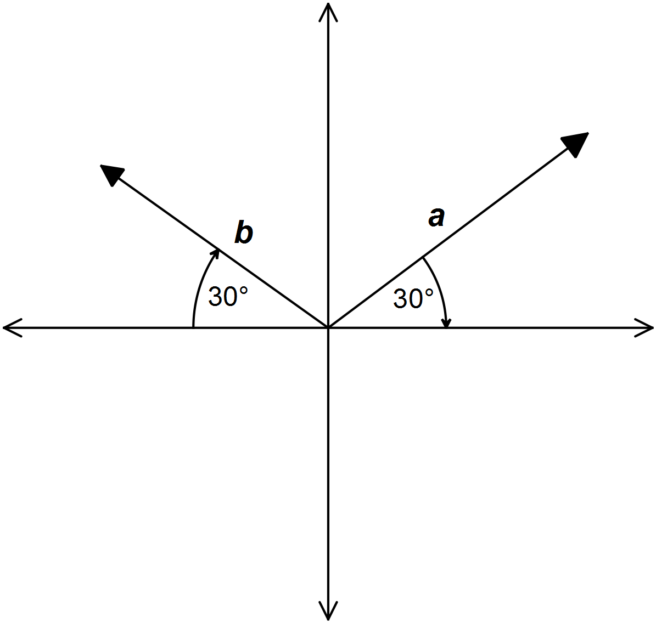

Determine the exact values of

(a) **a . a**

(b) **b . a**

**2.** [3 marks]

If  and , find m if is perpendicular to **b**.

**3.** [4 marks]

The vectors **a** and **b** are given by **a** = (5,12) and **b** = (2,-1).

Determine the **vector** projection of **a** on **b**.

4. [6 marks: 3, 3]

(a) A circle centred at O has s∠AOC = 140°, as shown in the diagram. Determine the values of *b* and *d*. Justify your answers.

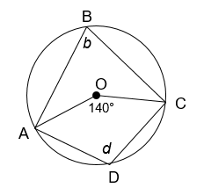

55°

S

T

O

x°

A

B

C

D

(b) A circle centred at O has a tangent ST as shown in the diagram. Given that s∠CDT = 55°, determine the value of x. Justify your answer.

**5.** [4 marks: 1,3]

A line drawn from a point A forms a tangent to a circle at B. A secant from A cuts through the same circle at point C and D.

A

B

C

D

(a) State a relationship between the lengths of the line segments AB, AD and AC.

(b) Hence prove that ΔABD ~ ΔACB.



**MATHEMATICS:**

**SPECIALIST 1 & 2**

**SEMESTER 1 2018**

**TEST 3**

**Name_____________________**

**Calculator Assumed**

Reading time: 3 mins

Time allowed: 32 mins Total marks: 33

**6.** [8 marks: 4, 4]

Three vectors are given by **a** = 7**i**, **b** = 6**i** +9**j** and **c** = $x$**i** – 5**j**.

(a) Calculate the angle between **a** and **b**. Give your answer to the nearest degree.

(b) Determine all possible values of  if (**a+c)** and (**b+c)** are perpendicular.

**7.** [7 marks: 4, 3]

(a) Vectors **a** and **b** have the same magnitude and vectors **a** and **c** are perpendicular, where  ,  and  Determine the values of  and .

(b) Determine the scalar projection of a velocity of 12 m/s on a bearing of 65º onto a velocity of 20 m/s on a bearing of 280º, giving your answer to three significant figures.

**8.** [10 marks: 3, 4, 3]

1. Determine the size of angle **a** in the diagram below.

A, B and C lie on a circle. DE is a tangent at C. AB = AC and DCA = 110°

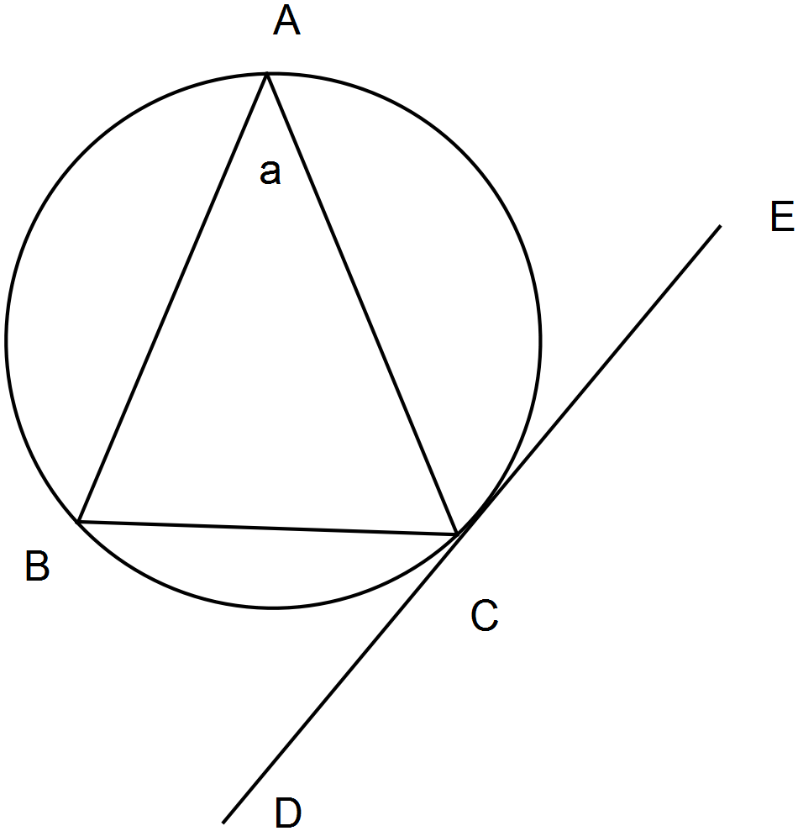

1. Determine the size of angle **b** in the diagram below.

P, Q and R lie on a circle. PQ is parallel to OR and ORQ = 68°, PRQ = b°,

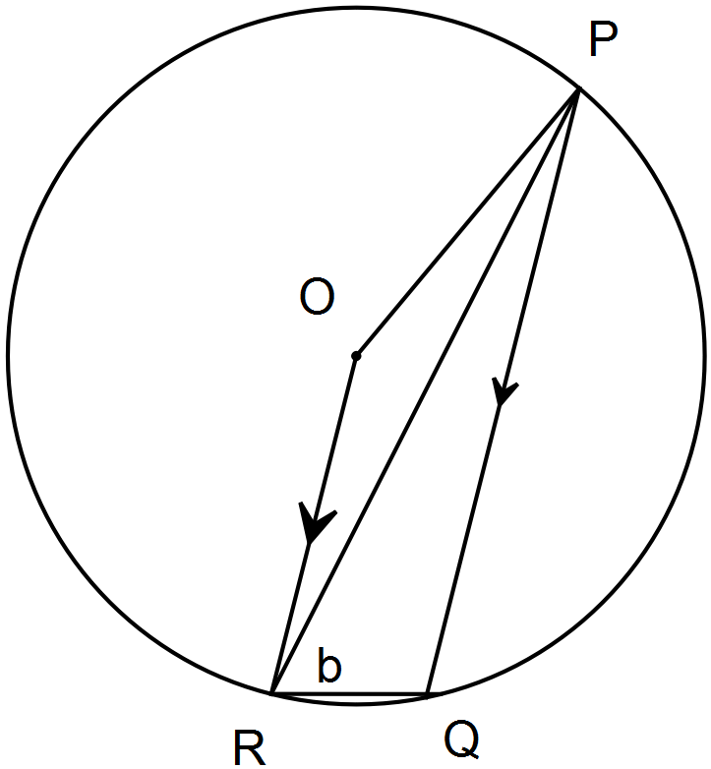

1. In the circle shown (not to scale), chords AC and BD intersect at E.

If AE = , BE = , CE =  and DE = , determine the length .

Justify your answer.

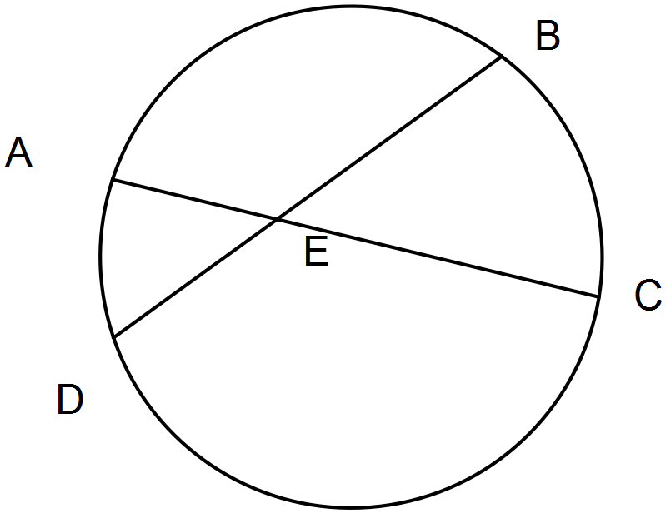

**9.** [4 marks]

O

A

B

C

**a**

**b**

Prove that if the diagonals of a rectangle are perpendicular then the rectangle is a square.

10. [4 marks]

Prove that the angle subtended by an arc at the centre of a circle is twice the angle subtended at any point on the circumference.

